Stage 3: Spread to Nearby Tissues
Stage 3 prostate cancer has grown outside the prostate gland and may have invaded nearby tissues such as the seminal vesicles or surrounding structures. PSA levels and Gleason scores are often higher.
This stage is considered locally advanced. Treatment is more complex and requires careful planning with a urologist or oncologist.
What to expect: urinary changes, possible pelvic discomfort, and discussions about more active treatment options such as surgery or radiotherapy.
What to do: follow your doctor’s recommendations, understand the benefits and risks of treatment, and consider support services for coping with advanced disease.
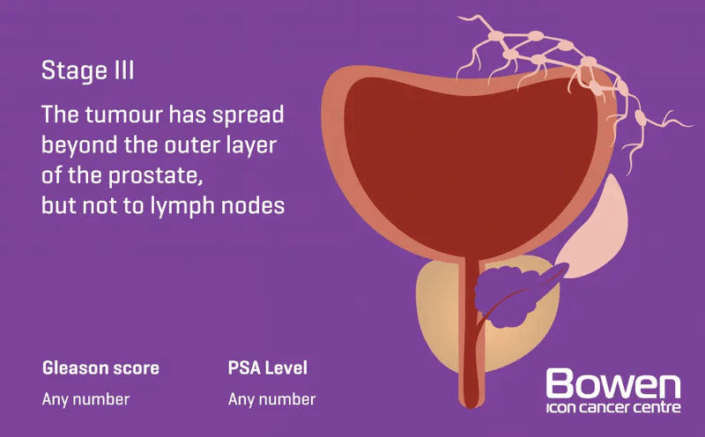
Image source: Bowen Icon Cancer Centre
Stage 3 highlights the importance of early detection. Men are encouraged to actively discuss treatment options and seek support.

